Now, instead of calling the Help Desk to update individual phone numbers, School Staff, Caretakers and Learning Coaches can update contact information in real time!

Look for the new “i” icon on the Student Log page that will take school staff to data views where they may update phone numbers for individual Caretakers, Learning Coaches, Students' mobile, or the Household!

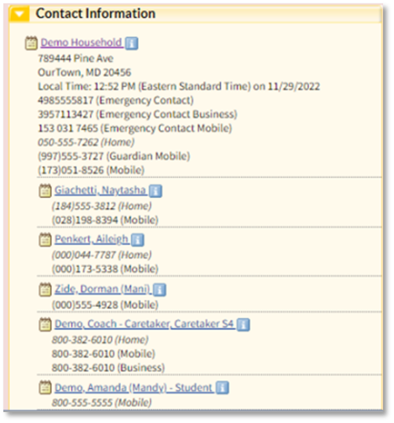
(Shown above: School staff view of the Contact Information section of the Student Log Page.)

For Caretakers and Learning Coaches, the ability to update individual phone numbers for themselves is now in their Pearson Online Classroom Data View list. In addition to the existing functionality to update Household information, Caretakers and Learning Coaches will have access to a new Data View to update personal phone numbers as shown below.

